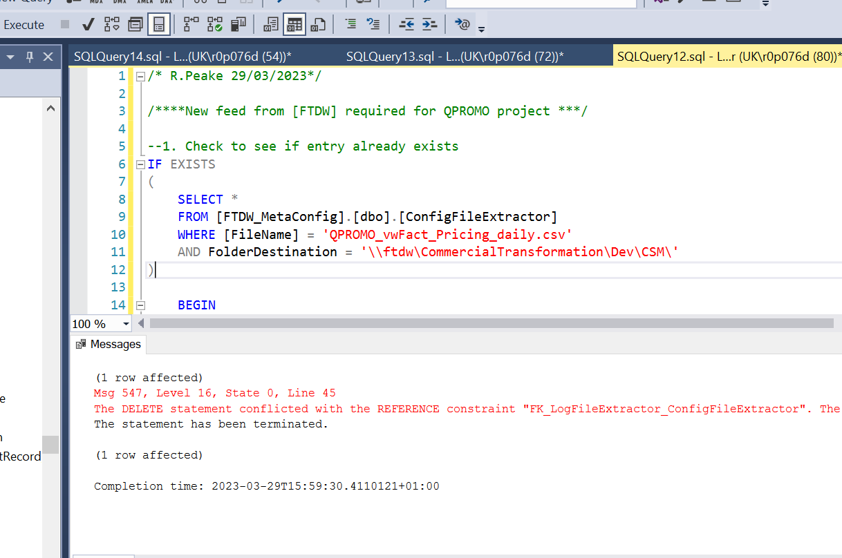

I’m not sure what the warning around the log file is? Perhaps because I executed a few times.

Both entries appear in the table after running the code.

